**CardGames Use Case Scenarios and Screenshots**

**Change Account Settings**

1. User clicks on the the "Change account settings" button

1.1 Account Settings GUI is displayed

1.1.1 If user selects "change password"

1.1.1.1 Account controller displays form to change password

1.1.2 else if user selects "change name"

1.1.2.1 Account controller displays form to change name

1.1.3 else if user selects "change email"

1.1.3.1 Account controller displays form to change email

1.2 User fills out specific form

1.2.1 Account controller passes users information to database manager

1.2.2 Database manager returns specific user

1.2.3 Database manager changes user's information

1.2.4 Account system creates confirmation message

1.2.5 Account settings GUI displays confirmation message



**Text Chat**

1 Table GUI displays text chat form

1.1 User types message into chat text box and hits send

1.1.1 Chat controller receives message

1.1.2 Chat controller sends message to other users through sockets

1.1.3 Table GUI displays chat message to every player



**Register**

1 User clicks on Login/Register button

1.1 user fills out registration form

1.2 Account controller validates form information

1.3 If information is valid

1.3.1 Account controller sends information to database manager

1.3.2 Database manager checks to see if user already exists

1.3.2.1 If user exists

1.3.2.1.1 Account controller creates error message

1.3.2.1.2 Register GUI displays error message

1.3.2.2 else

1.3.2.2.1 Database Manager adds new user

1.3.2.2.2 Account controller creates confirmation message

1.3.2.2.3 Register GUI displays confirmation message



**Login**

1 User Clicks on the login/register button

1.1 user fills out login form

1.1.1 Account controller validates form information

1.1.1.1 If information is valid

1.1.1.1.1 Account controller sends information to database manager

1.1.1.1.2 Database manager attempts to find user in the database

1.1.1.1.2.1 If user is found

1.1.1.1.2.1.1 Database manager sends user's information back to Account controller

1.1.1.1.2.1.2 Account controller validates that password is correct

1.1.1.1.2.1.2.1 If password is correct

1.1.1.1.2.1.2.1.1 Account controller creates session for user

1.1.1.1.2.1.2.1.2 Account controller reroutes user to home page

1.1.1.1.2.1.2.2 else if password is incorrect

1.1.1.1.2.1.2.2.1 Account controller creates error message

1.1.1.1.2.1.2.2.2 Login GUI displays error message

1.1.1.1.2.2 else if user isn't found

1.1.1.1.2.2.1 Account controller creates error message

1.1.1.1.2.2.2 Login GUI displays error message

1.1.1.1 else if form information isn't valid

1.1.1.1.1 Account controller creates error message

1.1.1.1.2 Login GUI displays error message



**Logout**

1 User clicks logout button

1.1 Account controller finds session id

1.2 Account controller stops session

1.3 Account controller creates logout message

1.4 Account controller reroutes to logout page

1.5 Logout GUI displays logout message



**View User Statistics**

1. User clicks on a player’s username

2.1 Card Game System GUI sends request to account controller

2.2. Account controller passes username to DBManager for retrieval

2.3 DBManager searches for user's information, u, sends requested statistics back to Card Game System GUI

2.4 Card Game System displays the user's statistics on the user's profile page and takes the user to the profile page.

3. User reads statistics and profile information.



**Join a Card Game**

1. User clicks on the card game they wish to play

2. Card Game System GUI takes them to a list of available tables for the selected card game

3.1 Player clicks Join Table on the table they wish to play at.

3.2 Card Game System GUI sends request to join table to the specified game's controller.

3.2.1 If the table is full

3.2.1.1 Card Game System GUI displays “Table is Full, cannot join table”.

3.2.2 Else,

3.2.2.1 Game controller accepts user information from Card Game System GUI and lets

the user join the table

4. The Game controller seats the user

5. The Card Game System GUI displays the table the user has successfully joined.

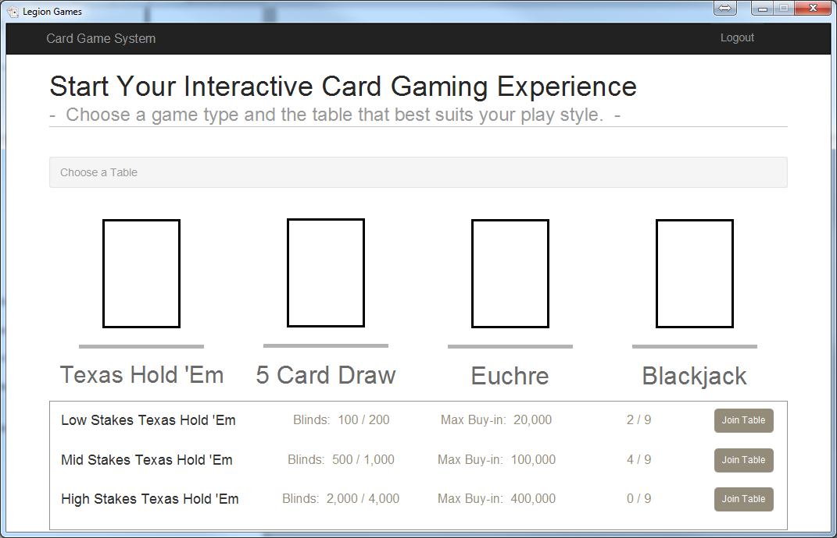



**Playing a Texas Hold ‘em Hand**

0.1. Holdem controller calls on HoldemDealer object hd to start a new hand

0.1.1 hd uses a Deck d to deal cards to a list of Players, players

0.2 Holdem Controller retrieves information from hd about players, and passes hand information to GUI

1. User completes Use Case “Poker Betting Action”

2. Holdem controller checks if betting is complete

2.1 If betting isn’t complete

2.1.1 Continue processing betting actions

2.2 Else

2.2.1 If there is more than one player remaining

2.2.1.1Controller calls to hd to deal flop, and receives cards dealt

2.2.1.2 GUI displays cards to the user

2.2.2 Else

2.2.2.1 Award the pot to the remaining player

3. User completes UC Poker Betting Action

3. Holdem controller checks if betting is complete

3.1 If betting isn’t complete

3.1.1 Continue processing betting actions

3.2 Else

3.2.1 If there is more than one player remaining

3.2.1.1Controller calls to hd to deal turn, and receives cards dealt

3.2.1.2 GUI displays cards to the user

3.2.2 Else

3.2.2.1 Award the pot to the remaining player

4. User completes UC Poker Betting Action

5. Holdem controller checks if betting is complete

5.1 If betting isn’t complete

5.1.1 Continue processing betting actions

5.2 Else

5.2.1 If there is more than one player remaining

5.2.1.1Controller calls to hd to deal river, and receives cards dealt

5.2.1.2 GUI displays cards to the user

5.2.2 Else

5.2.2.1 Award the pot to the remaining player

6. User completes UC Poker Betting Action

7. Holdem controller checks if betting is complete

7.1 If betting isn’t complete

7.1.1 Continue processing betting actions

7.2 Else

7.2.1 If there is more than one player remaining

7.2.1.1Controller calls to hd to find the winning hand

7.2.1.2 hd calls to HoldemWinChecker wc to find the winning hand

7.2.1.3 hd receives winning hand, and calls to bh to award the pot to the winining player

7.2.1.4 GUI displays hands in showdown and displays winning player

7.2.2 Else

7.2.2.1 Award the pot to the remaining player

8. Holdem controller passes list of Players to DBMgr and updates statistics



**Poker Betting Action (For any type of poker)**

1 User chooses action in GUI

2.1 GUI sends action to game controller

2.1.1 Controller sends action to poker Dealer object for game, d

2.1.2 d passes action to PokerBettingHelper bh

2.1.3 bh processes action and adjusts the chips of Player, p

3. Game controller calls retrieves updated chip count of p through d



**Starting a Euchre Hand**

1. Euchre controller calls on EuchreDealer object ed to start a new hand

1.1 ed uses Deck d to deal cards to players

1.3 ed returns dealt card information to controller

1.4 GUI retrieves and displays player hands

1.5 GUI displays potential trump card in the middle of the table

2.1 GUI retrieves current dealer from controller

2.2 GUI asks provides options to first player on the left of the dealer.

3. User either calls trump or passes to next player

